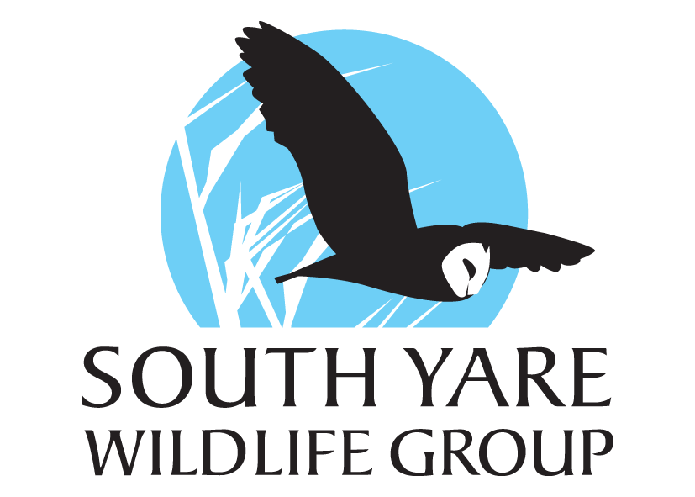
Events listings Summer, Autumn and Winter 2022
June 18th- Surlingham School fete. SYWG will have a stall here so come along and check us out.
June 19th- Wild Patch Open Gardens. See recent post.
July 8th- Hellington and Rockland reserve Wild Flower evening- SYWG members welcome. 6.30-7.30pm
July TBC- Bat Walk at Rockland Broad
August 21st- Loddon Jubilee Hall Wildlife Activities Afternoon. Excellent for families. 2-5pm.
August 28th- joint walk with Hellington and Rockland Group covering 4 churches. 2-4pm.
September TBC- Talk on Large Marsh Grasshopper Reintroduction
October 19th- Wild Ken Hill talk at Poringland community centre 7.30-9.30
November 16th- Joe Harkness talk on mental health and the natural world
December 4th- Winter Walk at Rockland with seasonal refreshments 2-4pm

